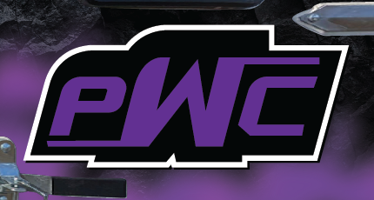
2026-27 SPONSORSHIP & COMMUNITY PARTNERSHIP PACKET
Pittsburg Wrestling Club
A place for kids to learn, compete and belong.
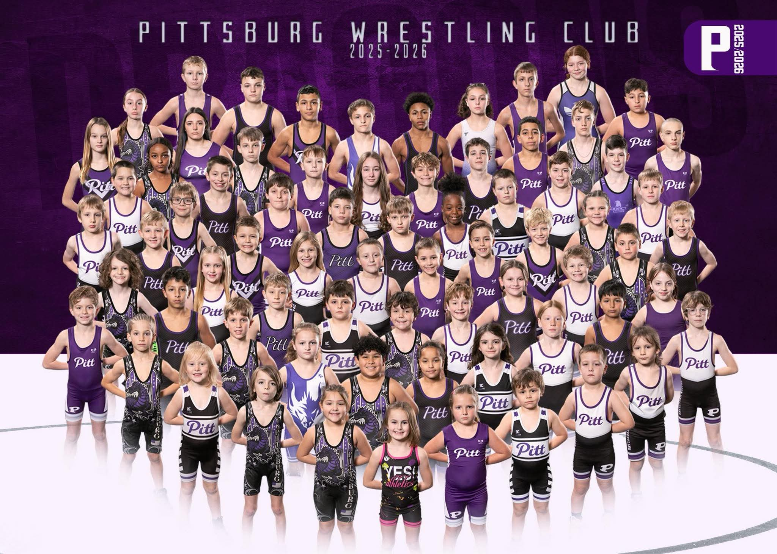
2027 PITTSBURG DRAGON  YOUTH TOURNAMENT  Sunday, February 7, 2027 | Pittsburg, Kansas  PWCdragons.org

Who We Are
Local kids. Volunteer coaches. A lot of time on the mat.

Pittsburg Wrestling Club is a local, volunteer-led youth program. We teach wrestling, but we also expect our kids to learn discipline, confidence, teamwork and respect. Most of all, we want them to have a good place to compete, improve and be part of a team.
DEVELOPMENT  From a first practice to Open competition and State, we want kids to have a next step. | ACCESS  Payment options and wrestler assistance help families when cost becomes a barrier.
COMMUNITY  Parents, coaches, schools and local businesses all help keep the club going. | OPPORTUNITY  Wrestlers can compete locally, travel regionally and work toward State as they improve.
How it works
- Novice gives newer wrestlers a place to learn the basics and build confidence.
- Open is for wrestlers ready for tougher practices, more technique and more competition.
- We have boys and girls throughout the program and support wrestlers who qualify for Kansas State.
- Pittsburg schools provide our practice room and home-tournament gym at no facility charge, which lets more club money stay focused on the kids.

Watching Kids Improve
We care about signups, but we care even more about kids improving, coming back and taking the next step.

123  approx. unique wrestlers  2025-26 | 18  youth State qualifiers  2026 | 44.4%  2026 youth State  placer rate
2026 State teams
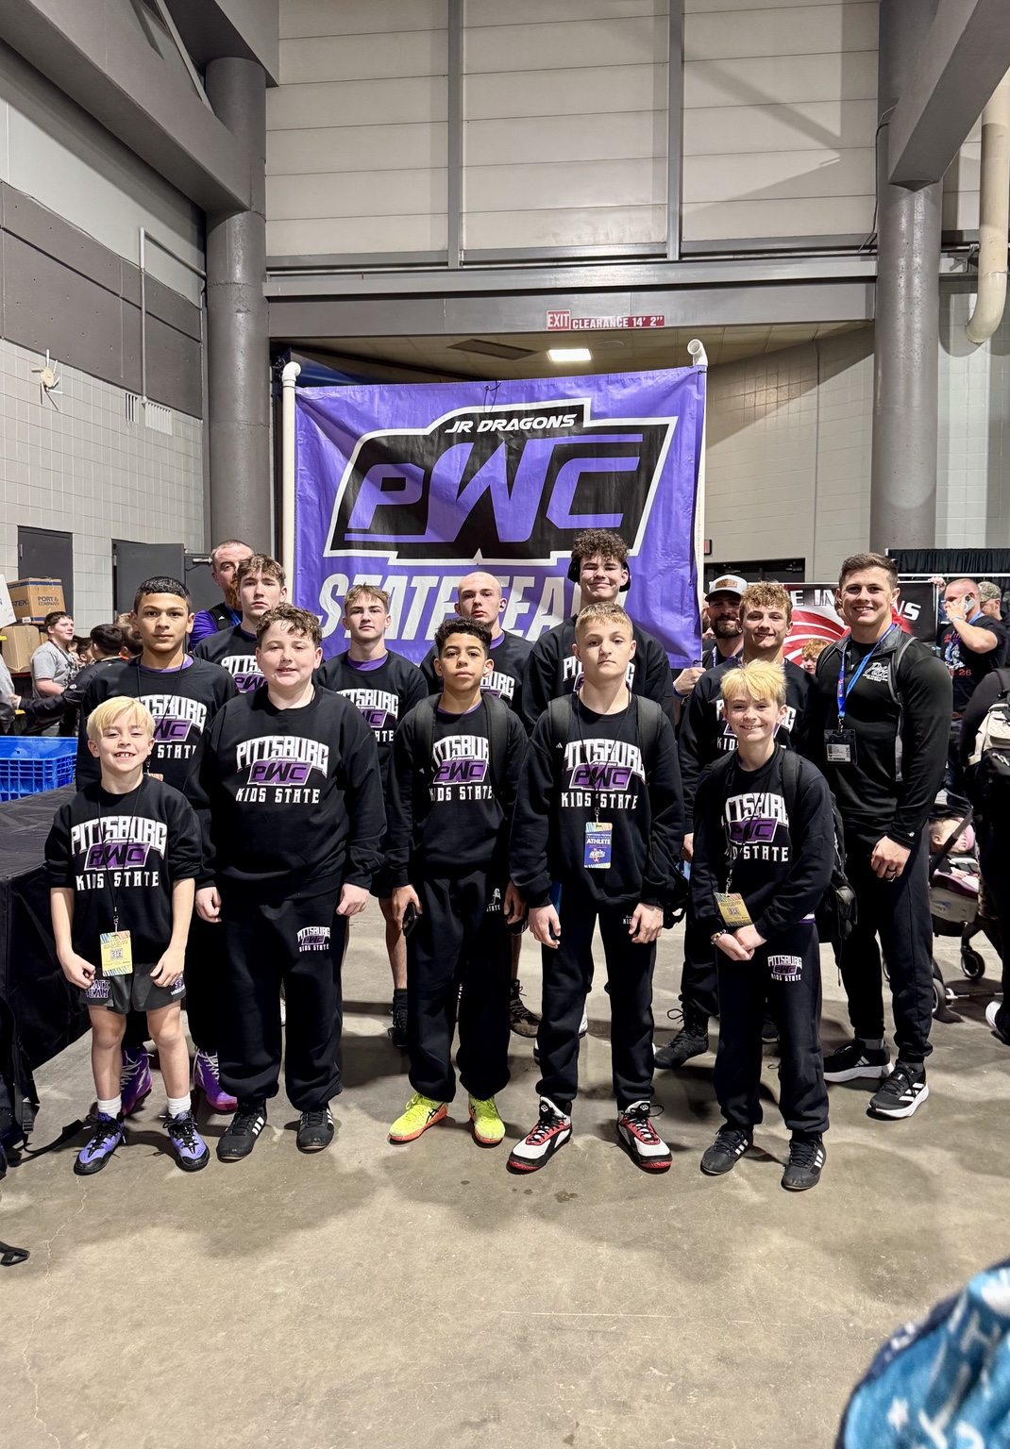  2026 Boys State Team | 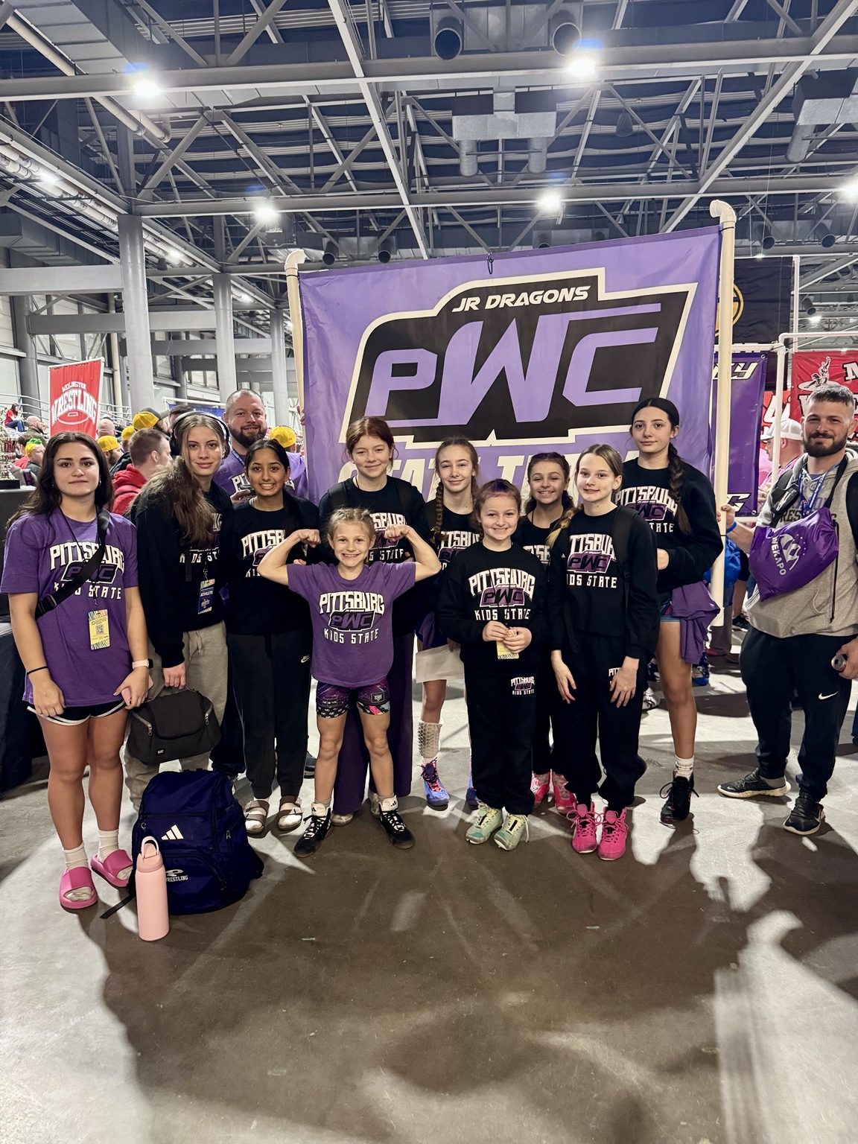  2026 Girls State Team
When wrestlers qualify for State, PWC helps make the experience special with State gear and coach support. We also helped send three wrestlers to Kansas Freestyle/Greco State last season.
For 2026-27, we are partnering with SEK Elite to offer additional wrestling opportunities. The final structure and optional details are still being worked out.

Making Wrestling Work for Families
We do not like turning a kid away because money is tight. When a family needs help, we try to make wrestling work.

FULL-SEASON ASSISTANCE  Last season, about 4-5 wrestlers received full club support, including dues, USA Wrestling membership and tournament entries. | PAYMENT FLEXIBILITY  Families can split club fees into payments, and we work with parents when paying everything at once is not realistic.
PROCESSING FEES  Families pay the actual tournament entry price - usually $25-$30 - and PWC absorbs the processing fees. | VOLUNTEER COACH FAMILIES  We also help with participation costs for the children of coaches and board volunteers who give significant time to the club.
Wrestler Assistance Fund
Businesses and individuals can give directly to wrestler assistance. Families apply through the club, and the board reviews requests so help goes where it is needed most.
$150  Registration  Support | $300  Two-Registration  Support | $500  Scholarship  Champion | $1,000+  Expanded  Scholarship Support
Every wrestler’s season looks different, so assistance is used where that family needs it most.

2027 Pittsburg Dragon Youth Tournament
Sunday, February 7, 2027 - Pittsburg High School - Pittsburg, Kansas

501  competitive entries  in 2026 | 59  clubs / teams | 4  states represented | 1,500+  estimated total  people through venue
In 2026, PWC had 501 competitive entries from 59 clubs and teams across four states, even with other SEK tournaments on the same date. One of the largest conflicts moves to the prior weekend in 2027.
Something Wrestlers Remember
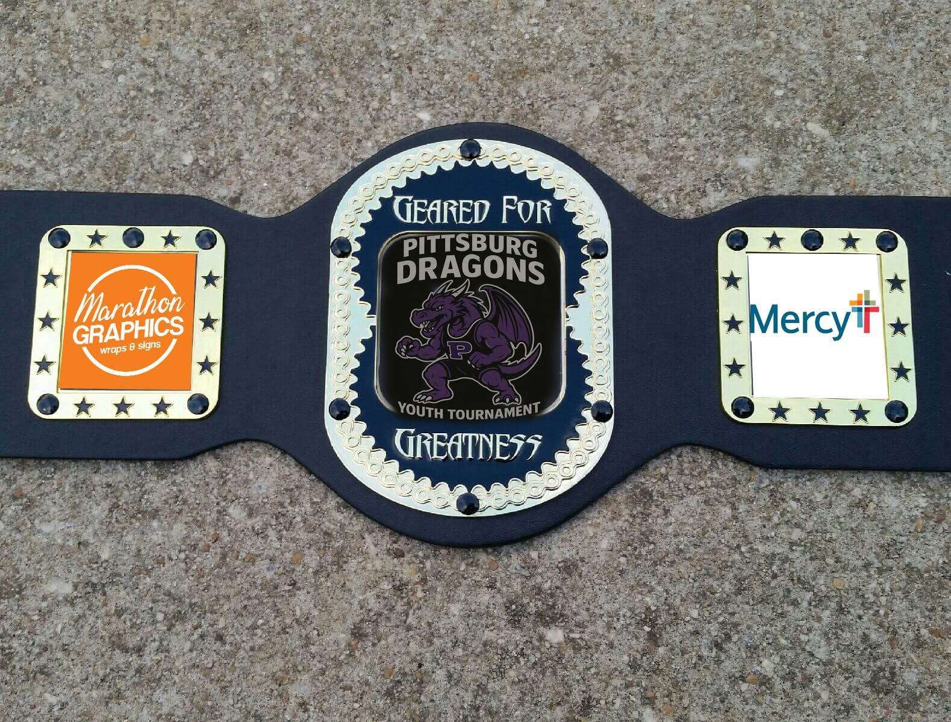  Championship belts introduced in 2026 | 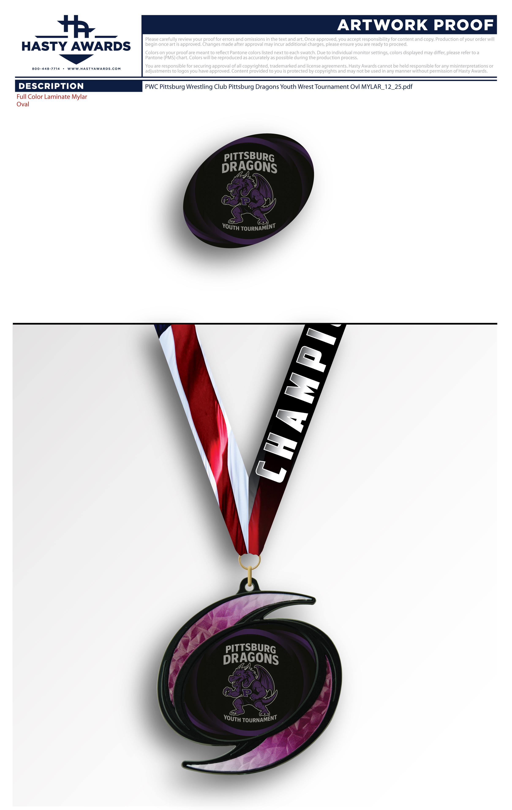  Custom tournament medal program
We introduced championship belts for Open winners in 2026 and are currently the only Southeast Kansas youth club offering them at its home tournament.

Championship Belt Sponsor
A highly visible sponsorship tied directly to the championship belts our Open winners take home.

$1,000
1 SPOT REMAINS
Mercy has already secured one of the two 2027 Belt Sponsor positions.
- Logo featured directly on the championship belts
- Premier recognition on PWC website and event materials
- Live tournament recognition throughout the day
- Prominent event signage
- Booth/table option when space allows
Why it stands out
A Belt Sponsor logo is not just on a banner for one day. It becomes part of an award a wrestler takes home and keeps.

Ways to Partner With PWC
Our regular sponsorships run through the season, with the February home tournament providing the biggest single day of visibility.

PARTNERSHIP | INVESTMENT | RECOGNITION
Community Supporter | $100 | - Business/name listed on sponsor page  - Group social-media thank-you  - Tournament announcement recognition
Bronze Partner | $250 | - Logo on sponsor page  - Social-media recognition  - Logo on tournament sponsor display  - Tournament announcement recognition
Gold Partner | $500 | All Bronze benefits  Dedicated social-media feature  Prominent tournament signage  Option to provide promotional materials  Booth/table option when space allows
Premier Partner | $1,000 | All Gold benefits  Top website placement  Multiple social-media features  Prominent tournament recognition  Season-long Premier recognition
Have another idea? We are open to it.
Not every partnership has to fit a package. Cash, products, services, raffle items, food, equipment and other ideas are all welcome.

Support Does Not Have to Be a Check
Food, services, equipment, raffle items and volunteer time can help just as much as cash.

HOSPITALITY  Food, drinks and snacks for coaches, officials, staff and volunteers. | RAFFLES & FUNDRAISING  Gift baskets, tickets, gift cards, merchandise and other fundraising items.
EQUIPMENT & SERVICES  TVs/monitors, printing, signage, graphics, lodging and other things we would otherwise buy. | WRESTLER & FAMILY SUPPORT  Scholarship funding, wellness/recovery services and other help that lowers family costs.
A few recent examples
Toast has donated hospitality trays for two years. White Elephant donated a raffle basket. The St. Louis Cardinals donated game tickets. Domino’s has given us the school rate and donated pizzas. Our parents bring food and supplies and volunteer throughout tournament day.
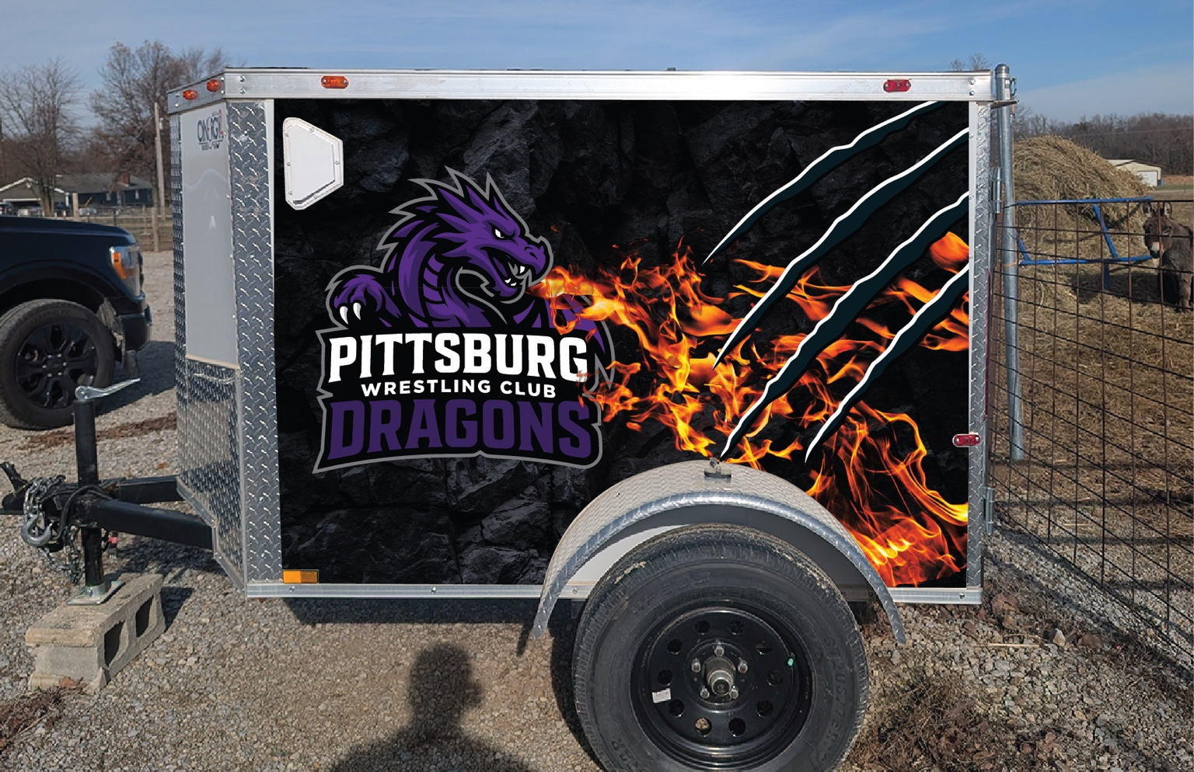 | 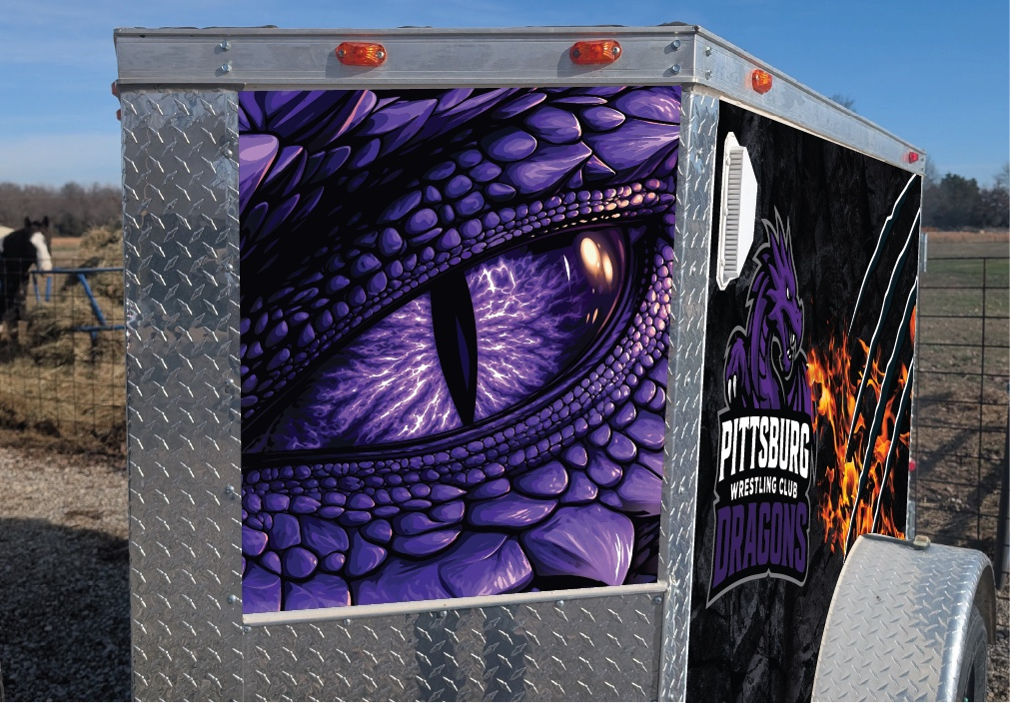
Our new club trailer will also put PWC out in the community throughout the season.
BECOME A PWC COMMUNITY PARTNER
Will Peden | 417-322-5848 | PittsburgWrestlingClub@gmail.com
PWCdragons.org
Custom, scholarship and in-kind partnerships are welcome.

